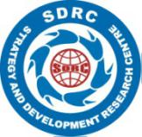 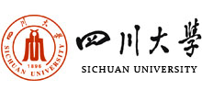 

  

2016 International Conference on Strategic Management

(5th ICSM)

# *Innovation, Entrepreneurship and Strategy*

# *in the Era of Internet*

# Call for Papers

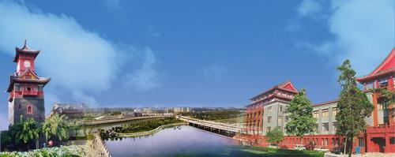

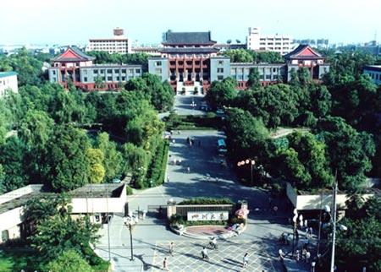

March 10-11, 2016, Chengdu, China

Conference Sponsor

Business School of Sichuan University, P.R. China

Conference Co-Sponsors

Auckland University of Technology, New Zealand

Boston College, USA

Eastern New Mexico University, USA

Economic Management Press, P.R. China

Swinburne University of Technology, Australia

The Chengdu People’s Association for Friendship with Foreign Countries, P.R. China

Conference Host

Strategy and Development Research Center of Sichuan University, P.R. China

Support Journals

International Journal of Tourism Anthropology, Swiss (Published and typeset in the UK)

International Journal of Business & Economics, Taiwan, P.R. China (Operated independently by an internationally oriented editorial board.)

Conference Committee

Conference Chairpersons

Jiuping Xu President Assistant, Sichuan University, P.R. China

Dean/Professor, Business School of Sichuan University, P.R. China

Conference Organizing Committee Chairperson

Xiaowen Jie Professor, Business School of Sichuan University, P.R. China

Director, Strategy and Development Research Center of Sichuan University,

P.R. China

Conference Organizing Committee Vice-Chairperson

Liming Zhang Deputy Secretary/Professor, Business School of Sichuan University, P.R. China

Academic Committee Chairpersons

Arch Woodside Professor, Carroll School of Management, Boston College, USA

Editor-in- Chief, *Journal of Business Research,* USA

Editor-in-Chief, *International Journal of Business & Economics,*

Co-founder of Advertising and Consumer Psychology Annual Meeting, USA

Member of the International Academy for the Study of Tourism, USA

Erming Xu Professor, Business School of Renmin University, P.R.China

Director, SME Research Center of Renmin University, P.R. China

Conference Theme

Innovation, Entrepreneurship and Strategy in the Era of Internet

Conference Sub-themes on Strategic Management

Behavioral Theory and Strategy between Enterprises

Enterprise transformation and upgrading in the Era of Internet

Entrepreneurship and Development Strategy on SMEs

From Chinese Manufacture to Intelligent Manufacture in the Era of Internet

“Internet +”and Transformation of Traditional Industries

Enterprise Management and Tactics

Chinese National Strategy “OBAOR” and Regional Economic Development

Regional Environmental Conservation and Sustainable Development

Managing Luxury Brands Worldly

Service and Product Management

Decision-making and experiments

Conference Sub-themes on Tourism Management

“Internet +”and Smart Tourism

Tourism Behavior, Mobility and Strategic Response

Sustainability in Urban and Rural Tourism

Construction and Traveling Development of Heritage-type Destinations

Strategy and Practice of Eco-tourism

Tourism Entrepreneurship, Innovation and Transformation

The submitted papers should be written in English with Microsoft Word 2007 or higher edition. Authors should identify the primary subtheme where their abstract/paper should be placed. The abstract should describe the paper’s contents and briefly explain the paper’s relevance to the conference theme. Abstracts must identify the author(s) affiliation, email address, and not exceed one page.

The Proceedings of 2016 ICSM will be indexed by ISI Proceedings (Conference Proceedings Citation Index - Social Science & Humanities CPCI-SSH, named in the Index to Social Science and Humanities Proceedings - ISSHP) through ISI Web of Knowledge in the United States. ICSM Proceedings have been collected in the data base of ISI since 2007 consecutively.

Six outstanding papers will be selected in the *International Journal of Business & Economics* after peer reviews. This journal is rated "B" in a recent ranking made by the Australian Business Deans Council (ABDC). The contents of *International Journal of Business and Economics* are abstracted and indexed by EconLit (including the Journal of Economic Literature), EBSCO, ProQuest, and Cabell's.

Important Dates

Paper Abstract Due:  October 30, 2015

Full Paper Due:  December 10, 2015

Paper Acceptance Notification by: December 30, 2015

Contacts

Issues Relating to Letter of Invitation,

Visa Application and Accommodations,

Registrations,

are to be e-mailed to:

icsm2016_info[@163.com](mailto:Tstan77346@gmail.com)

To the attention of:

Xiaoping Li,

Dean Assistant, Business School, Sichuan University, P.R. China

Post Code: 610065

Tel: (+86) 028-85410771

Paper Submissions

(in Microsoft Word)

are to be e-mailed to:

[icsm2016@163.com](mailto:icsm2016@163.com)

To the attention of:

Changyi Zhao,

Associate Professor, Business School,

Sichuan University, P.R. China

Post Code: 610065

Tel: (+86) 028-85410771

More information on 2016 ICSM will be released regularly at conference website: [www.icsm.com.cn](http://www.icsm.com.cn/)

Conference Venue: Business School of Sichuan University, Chengdu, China

Registration Day: March 9, 2016

Conference Days: March 10-11, 2016

Should any urgent inquiry, please feel free to contact by (86)028-85410771

Conference Agenda

2016 ICSM Key note Speeches and Panel Sessions: March 10, 2016

One day workshop on *“****Quantitative Modeling of Case-Level Data and How to Publish in A* and A Ranked Journals****”:* March 11, 2016

*Presented by* by 2016 ICSM Academic Committee Chairperson Prof. Arch Woodside,.

P.S: **The one day free workshop is available for registered attendees only. Due to limited places, the work shop applies the rule of First come ,First Reserve. The registered attendees will receive relevant papers from Prof. Arch Woodside before attending the work shop.**

Conference Fee

|  |  |
| --- | --- |
| Items | **Fee** |
| Registration fee | $100 dollars per person |
| Accommodation/Transportation | Accommodation& transportation are arranged by 2016 ICSM Organizing Committee while the accommodation is at attendee’s **own expense.** |

2016 ICSM Academic Committee Members

Janet Buzzard Professor/Dean, College of Business, Eastern New Mexico University, USA

Weizheng Chen Professor, Business School of Sichuan University, P.R.China

Li Cheng Professor, School of History &Culture (Tourism) of Sichuan University, P.R.China

Renyong Chi Dean/Professor, Research Institute of small and medium enterprises, Zhejiang University of Technology, P.R.China

Zhongwei Chen Vice-president/Professor, Anhui University of Finance and

Economics, P.R.China

Shengdao Gan Professor, Business School of Sichuan University, P.R.China

Xin Gu Deputy Dean/Professor, Business School of Sichuan University, P.R.China

Dengshi Huang Deputy Dean/Professor, School of Economics and Management,

Southwest Jiaotong University, P.R.China

Xu Huang Professor, School of Business Administration,

Southwestern University of Finance and Economics, P.R.China

Runtian Jing Professor, Antai College of Economics & Management,

Shanghai Jiaotong University, P.R.China

Shiming Li Professor, School of Economics and Management, University of

Electronic Science and Technology of China, P.R.China

Director, Institute of Development Studies, School of Economics

and Management, P.R.China

Yong Long Deputy Dean/Professor, School of Economics and Business

Administration, Chongqing University, P.R.China

Vice-Chairman, The Association of International Supply Chain and

Operations Management (ASCOM), P.R. China

Yongkai Ma Dean/Professor, School of Economics and Management,

University of Electronic Science and Technology of China, P.R. China

Daowei Mao Professor, Business school of Sichuan University, P.R.China

Wei Li Professor, Business School of Sichuan University, P.R.China

Peiyu Ren Professor, Business School of Sichuan University, P.R.China

Yonggui Wang Deputy Dean/Professor, Business School, University of International Business and Economics, P.R.China

Zhilong Tian Professor, School of Management, Huazhong University of

Science and Technology, P.R.China

Director, Marketing Association of Hubei Province

Vice-chairman, the Teaching Committee of Industry and

Commerce Management in Ministry of Education, P.R.China

Xiaobo Wu Dean/Professor, School of Management, Zhejiang University, P.R.China

Qinghua Xia Dean/Professor, Entrepreneurship and economic research center of

Wuhan University, P.R.China

Yuli Zhang Dean/ Professor, Business School of Nankai University, P.R.China

Shurong Zhao Professor, School of Political Science and Public Administration,

University of Electronic Science and Technology of China, P.R.China

Guangzheng Zhang President/Professor, Chung Yuan University, Taiwan, P.R. China

Xiaohu Zhou Deputy Dean/Professor, College of Entrepreneurship education,

Nanjing University of Science and Technology, P.R.China

Looking forward to meeting you

at 2016 International Conference on Strategic Management (5th) !

# Sichuan University

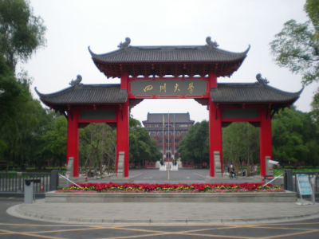Sichuan University is one of China’s key universities under the direct supervision of Ministry of Education. Located in downtown Chengdu, a famous historic and cultural city known as “the land of abundance”. It consists of three campuses of Wangjiang, Huaxi and Jiangan, and covers an area of 7050 mu (470 hectares) with a floor area of 308 hectares. The University, with its favorable environment and beautiful scenery, is a wonderful place for learning and doing research.

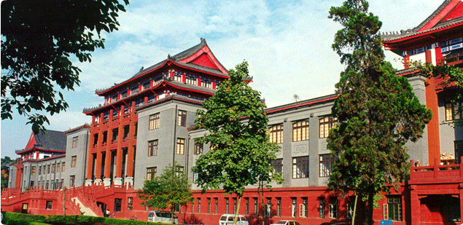Sichuan University has a comprehensive range of disciplines covering 11 categories, namely, liberal arts, science, engineering, medicine, economy, management, law, history, philosophy, agriculture and education. It consists of 30 colleges, including a postgraduate college and an overseas education college. Sichuan University has 27 primary disciplines which offer doctor and master degrees. Besides, the University offers 229 doctoral programs, 346 master programs, 13 professional master’s programs, 126 undergraduate programs, and 28 post-doctoral research stations. It also has 46 national key disciplines and 4 national key cultivated disciplines. There are 4 affiliated hospitals to the university under the direct supervision of Ministry of Health.

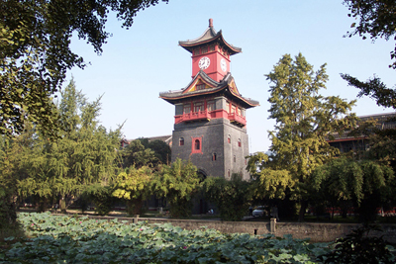In its long history of practicing education, Sichuan University has formed a rich culture and solid foundation of education. The motto of the university is: the ocean is exclusive because it embraces hundreds of rivers, and its spirit is embodied in the following four words: preciseness, diligence, truth-seeking and innovation.

# The Proud Legacy of the ICSM

2013 International Conference on Strategic Management (4th ICSM)

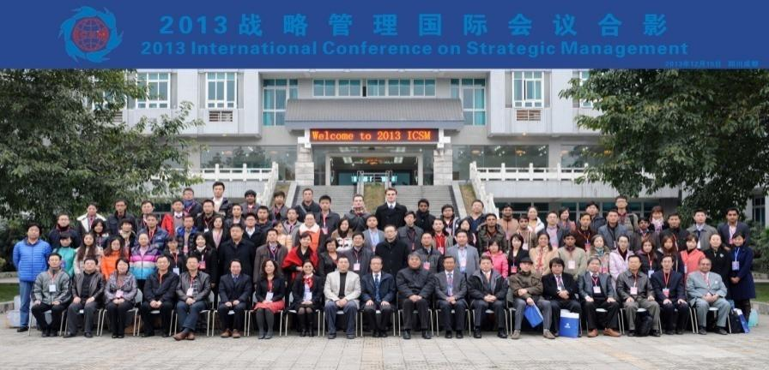

Theme: Strategy in Emerging Markets: Management, Finance and Sustainable Development

Date: December 15 - 16, 2013,Venue: Sichuan University, Sichuan, P.R. China

2011 International Conference on Strategic Management (3th ICSM)

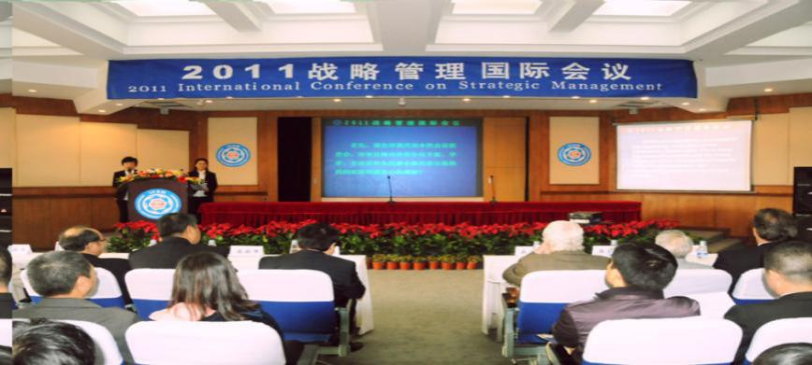

Theme: Environment, Low carbon and Strategic

Date: September 24 - 26, 2011

Venue: Sichuan University & Ganzi Tibetan Autonomous Prefecture, Sichuan, P.R. China

2009 International Conference on Strategic Management (2th ICSM)

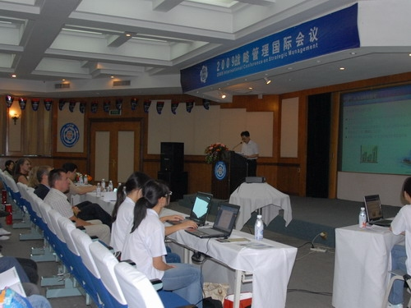

Theme: Strategic Innovation and Sustainable Development

Date: June 25, 2009 Venue: Sichuan University, Sichuan, P.R. China

2007 International Conference on Strategic Management (1th ICSM)

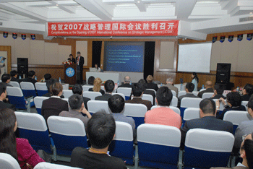

Theme: Strategic innovation and Sustainable Development of Chinese Enterprises

in the Transitional Period

Date: April 19-20, 2007Venue: Sichuan University, Sichuan, P.R. China